**Exercise 3.2**

1. Step 1: *Conclusion*:Jack is lying. *Premises*: Either Jack is lying or he is not. If his ears turn red, he’s lying. If they don’t turn red, he’s telling the truth. His ears are red.

Step 2: Deductively valid.

Step 3: Does not apply.

Step 4: Does not apply.

2. Step 1: *Conclusion*: She has a superior intellect. *Premises*: Ethel graduated from Yale. If she graduated from Yale, she probably has a superior intellect.

Step 2: Not deductively valid.

Step 3: Does not apply.

Step 4: Does not apply.

3. Step 1: *Conclusion*:You’re nuts. *Premises*: If you go to that party, you’re completely nuts. You’re going to the party.

Step 2: Deductively valid.

Step 3: Does not apply.

Step 4: Does not apply.

4. Step 1: *Conclusion*: Good sense is of all things in the world the most equally distributed. *Premises*: Everybody thinks himself so abundantly provided with it, that even those most difficult to please in all other matters do not commonly desire more of it than they already possess.

Step 2: Not deductively valid.

Step 3: Not inductively strong.

Step 4: Inductively weak.

5. Step 1: *Conclusion*: All absent-minded people are teachers. *Premises*: All philosophers are absent-minded. All philosophers are teachers.

Step 2: Not deductively valid.

Step 3: Not inductively strong.

Step 4: Deductively invalid.

6. Step 1: *Conclusion:* Thus, every musician has a college degree. *Premises:* Every musician has had special training, and everyone with special training has a college degree.

Step 2: Deductively valid.

Step 3: Does not apply.

Step 4: Does not apply.

7. Step 1: *Conclusion*: People with high SAT scores⎯which are comparable to high IQ scores⎯also probably have psychic abilities. *Premises*: People with high IQs also have psychic abilities.

Step 2: Not deductively valid.

Step 3: Not inductively strong.

Step 4: Inductively weak.

8. Step 1: *Conclusion*: There’s a conspiracy. *Premises*: If Elvis Presley’s name is spelled wrong on his tombstone, there must be some kind of conspiracy surrounding the death of the King. His name is spelled wrong.

Step 2: Deductively valid.

Step 3: Does not apply.

Step 4: Does not apply.

9. Step 1: *Conclusion:* Some actors who sing also play a musical instrument. *Premises:* Some actors sing, and some play a musical instrument.

Step 2: Deductively invalid.

Step 3: Not inductively strong.

Step 4: Intended to be deductive.

10. Step 1: *Conclusion*: Some people in this neighborhood are bigots. *Premises*: Anyone who is not a bigot will agree that Chris is a good fellow. Some people in this neighborhood think that he’s anything but a good fellow.

Step 2: Deductively valid.

Step 3: Does not apply.

Step 4: Does not apply.

11. Step 1: *Conclusion*: In the actual living of life there is no logic. *Premise*: Life is superior to logic.

Step 2: Not deductively valid.

Step 3: Not inductively strong.

Step 4: Deductively invalid.

12. Step 1: *Conclusion*: Someone obviously burglarized the place. *Premises*: A vase was found broken on the floor; some money had been taken out of the safe; and there were strange scratches on the wall.

Step 2: Not deductively valid.

Step 3: Inductively strong.

Step 4: Does not apply.

13. Step 1: *Conclusion*: She’s probably guilty. *Premises*: All the evidence in this trial suggests that Lizzy Borden is guilty of murder.

Step 2: Not deductively valid.

Step 3: Inductively strong.

Step 4: Does not apply.

14. Step 1: *Conclusion*: Everything is not all right. *Premises*: If everything were all right, there would be no blood on the floor. Of course, there is plenty of blood on the floor.

Step 2: Deductively valid.

Step 3: Does not apply.

Step 4: Does not apply.

15. Step 1: *Conclusion:* So, it’s impossible for androids to have minds. *Premises:* If minds are identical to brains⎯that is, if one’s mind is nothing but a brain⎯androids could never have minds because they wouldn’t have brains. Clearly, a mind is nothing but a brain.

Step 2: Deductively valid.

Step 3: Does not apply.

Step 4: Does not apply.

16. Step 1: *Conclusion*: Her training and education must be directed toward that end. *Premises*: From infancy, almost, the average girl is told that marriage is her ultimate goal.

Step 2: Not deductively valid.

Step 3: Not inductively strong.

Step 4: Inductively weak.

17. Step 1: *Conclusion*: Doubtless you have been visited by space aliens. *Premises*: If you have scratches on your body that you can’t account for, and you feel that you have been visited by space aliens, then you really have been visited by space aliens. You have such scratches, and you have experienced such feelings.

Step 2: Deductively valid.

Step 3: Does not apply.

Step 4: Does not apply.

18. Step 1: *Conclusion*: War has begun. *Premises*: If bombs are falling on London, war has started. The bombs are falling now.

Step 2: Deductively valid.

Step 3: Does not apply.

Step 4: Does not apply.

**Exercise 3.3**

1. Weak

2. Valid

3. Valid

4. Valid

5. Strong

6. Valid

7. Valid

8. Valid

9. Weak

10. Weak

11. Weak

12. Valid

13. Strong

14. Valid

15. Weak

16. Valid

17. Valid

18. Valid

19. Weak

20. Valid

21. Strong

22. Invalid

23. Invalid

**Exercise 3.5**

1. Valid; modus tollens

2. Valid; modus ponens

3. Valid; disjunctive syllogism

4. Invalid; affirming the consequent

5. Invalid; denying the antecedent

6. Valid; modus tollens

7. Invalid; affirming the consequent

8. Invalid; denying the antecedent

9. Valid; modus ponens

10. Valid; modus tollens

11. Invalid; affirming the consequent

12. Valid; hypothetical syllogism

**Exercise 3.9**

1. (1) I shouldn’t take physics this semester. (2) My course load is already too heavy. (3) There’s no room for the course in my schedule. (4) And I don’t like physics.

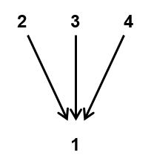

2. (1) The president is soft on the environment. (2) He has weakened clean-air regulations (3) and lifted restrictions on logging in the West.

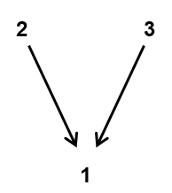

3. (1) Congressman Porkbarrel is either dishonest or incompetent. (2) He’s not incompetent, though, because he’s expert at getting self-serving legislation through Congress. (3) I guess he’s just dishonest.

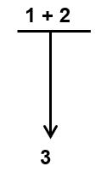

4. (1) If an individual in a coma is no longer a person, then giving him a drug to kill him is not murder. (2) Such an individual is in fact not a person. (3) Therefore, giving him the drug is not murder.

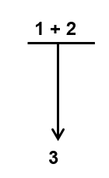

5. (1) The City Council deserves the gratitude of all New Yorkers for introducing a bill to ban the use of cell phones in places of public performance. (2) These rules may be hard to enforce, but so are bans on littering, auto horn honking, and other quality-of-life offenses. (3) By changing the law, the city will send a clear message that cell phone abuse is not just an etiquette issue but robs audience members of their right to enjoy the performance they paid for.

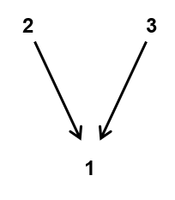

6. (1) If Marla buys the house in the suburbs, she will be happier and healthier. (2) She is buying the house in the suburbs. (3) So, she will be happier and healthier.

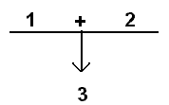

7. (1) If you gain too much weight, your blood pressure will increase. (2) If your blood pressure increases, your risk of stroke or heart attack rises. (3) Therefore, gaining too much weight can increase your risk of stroke and heart attack.

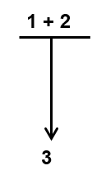

8. (1) Grow accustomed to the belief that death is nothing to us, (2) since every good and evil lie in sensation. (3) However, death is the deprivation of sensation. (4) Therefore, death is nothing to us.

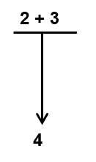

9. (1) A cause-and-effect relationship is drawn [by those opposed to pornography] between men viewing pornography and men attacking women, especially in the form of rape. (2) But studies and experts disagree as to whether any relationship exists between pornography and violence, between images and behavior. (3) Even the pro-censorship Meese Commission Report admitted that the data connecting pornography to violence was unreliable. *Implied*: (4) Therefore, the alleged cause-and-effect relationship is dubious.

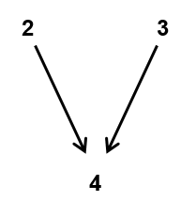

10. (1) The existence of planets outside our solar system is a myth. (2) There is no reliable empirical evidence at all showing that planets exist outside our solar system.



11. (1) If Li Yang gets a high score on her test, she will have a perfect grade point average. (2) If she gets a low score, she will drop out of school. (3) She will get a high score on the test, (4) so she will have a perfect grade point average.

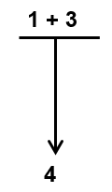

12. (1) Most atheists are liberals, and (2) George is an atheist. Therefore, (3) George is probably a liberal. (4) Therefore, George is probably in favor of increased welfare benefits (5) because most liberals are in favor of increased welfare benefits.

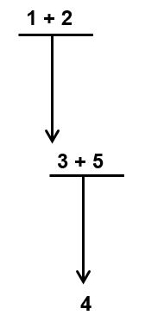

13. (1) Bill is a student at Yale. (2) No student at Yale has won the Nobel Prize. (3) Therefore, Bill has not won the Nobel Prize.

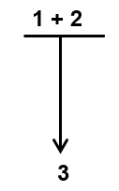

14. (1) An international agreement proscribes the use of gas, and (2) so germ warfare must be developed.



15. (1) The only valid reasons for dishonorably discharging someone from the army are health problems and violations of army regulations. (2) So, if Amal says that he was dishonorably discharged for simply being gay, he is lying or is mistaken. (3) He is not lying. (4) So he is mistaken.

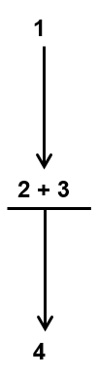

16. (1) It is clear that archaeologists have not yet come to terms with dowsing [the alleged ability to detect underground water or treasure by paranormal means]. (2) Where it has been the subject of tests, the tests have been so poorly designed and executed that any conclusion whatsoever could have been drawn from them. (3) The fact that such tests are usually carried out only by researchers with a prior positive view of dowsing means that the conclusions will likely also be positive. (4) The normal processes of peer review and scholarly discussion have also failed to uncover the lack of properly controlled test conditions in such studies as those of Bailey, et al. and Locock, causing a generation of students and general readers in the United Kingdom, at least, to remain under the impression that the reality of archaeological dowsing had been all but confirmed by science.

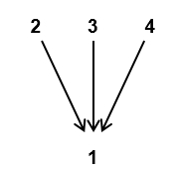

17. (1) There are at least two main views regarding the morality of war. (2) Pacifism is the view that no war is ever justified because it involves the taking of human life. (3) Just-war theory is the view that some wars are justified for various reasons⎯mostly because they help prevent great evils (such as massacres, “ethnic cleansing,” or world domination by a madman like Hitler) or because they are a means of self-defense. (4) I think that our own moral sense tells us that sometimes (in the case of World War II, for example) violence is occasionally morally justified. (5) It would be hard for anyone to deny that a war to prevent something like the Holocaust is morally right. [Implied conclusion] (6) Just-war theory is correct.

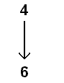

18. (1) Some say that those without strong religious beliefs⎯nonbelievers in one form or another⎯cannot be moral. (2) But millions upon millions of people have been nonbelievers or nontheists and yet have produced some of the most noble and most morally principled civilizations in history. (3) Consider the Buddhists of Asia and the Confucianists of China. (4) Consider also the great secular philosophers from the ancient Greeks to the likes of Bertrand Russell and John Searle of the twentieth century. (5) *Implied*: It’s not true that those without strong religious beliefs cannot be moral.

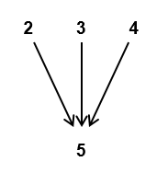

19. (1) Either Maggie, José, or Ling broke the window. (2) José couldn’t have done it because he was studying in his room and was observed the whole time. (3) Maggie couldn’t have done it because she was out of town at the time and has witnesses to prove it. (4) So, the thief had to be Ling.

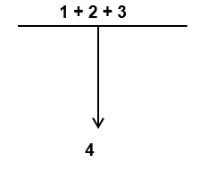

20. (1) The picnic will probably be spoiled because (2) there is a 90 percent probability of rain.



21. (1) The Golden Gate Bridge will probably be attacked by terrorists within the next two years. (2) The latest intelligence reports from the Justice Department confirm this prediction. (3) Plus, terrorists have already stated publicly that they intend to destroy various symbolic structures or monuments in the United States, including Mount Rushmore and the Golden Gate.

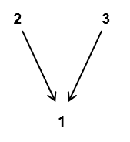

22. (1) We shouldn’t pay Edward an allowance (2) because he never does any work around the house, and (3) he will probably just waste the money because (4) he has no conception of the value of anything.

